


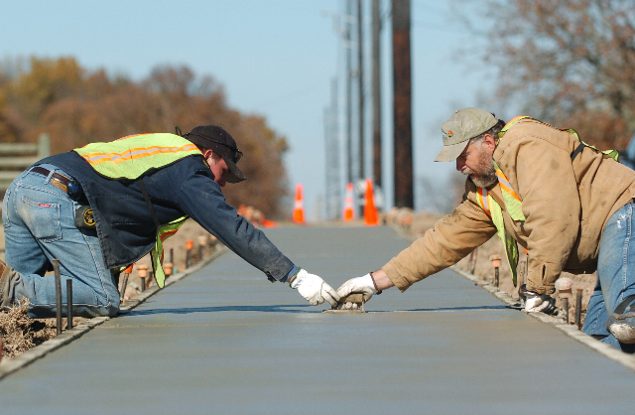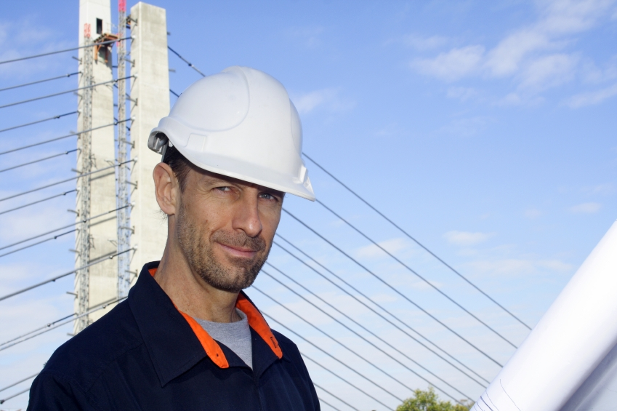

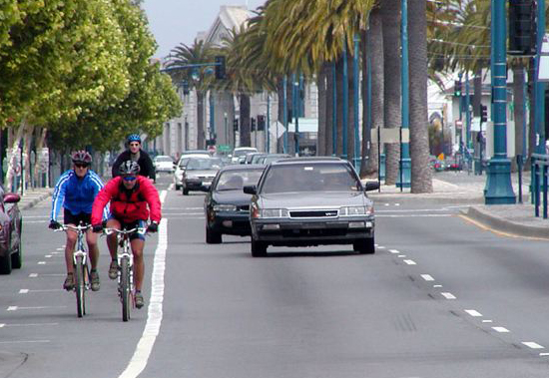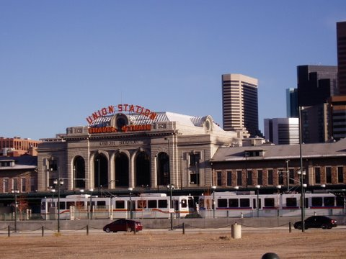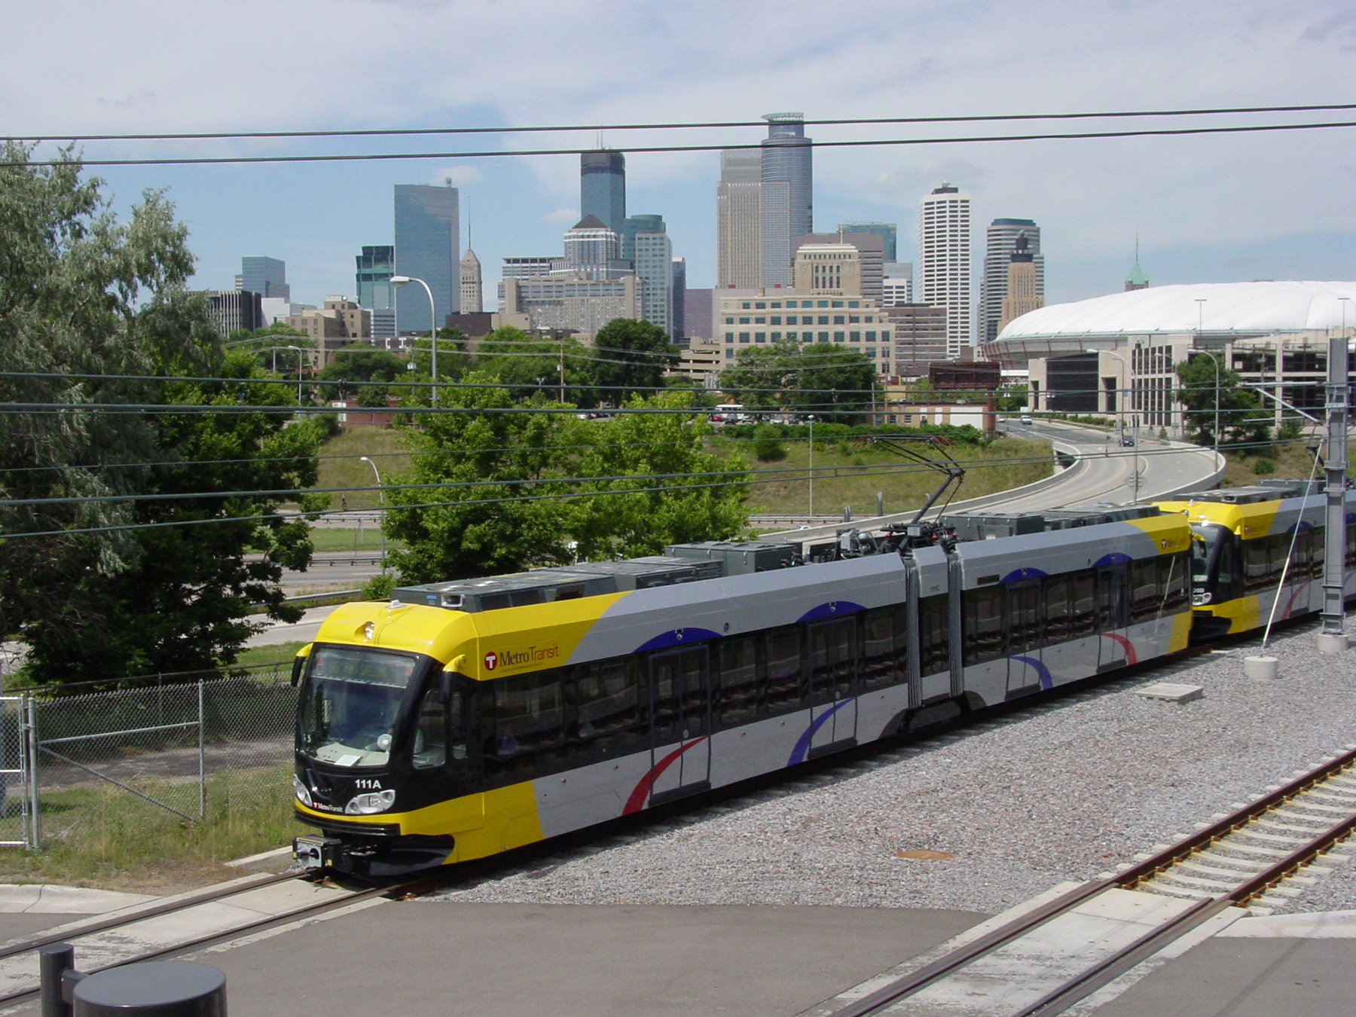

Spending the Stimulus
How California Can Put Thousands Back to Work
& Jump-start a 21st Century Transportation System

Spending the Stimulus

How California Can Put Thousands Back to Work
& Jump-start a 21st Century Transportation System

Executive Summary
As families all over America struggle to make ends meet, officials are under pressure to make the best use of the federal stimulus money soon to pour into state capitals. The American Recovery and Reinvestment Act (ARRA) is a critical opportunity for state and local officials to help those families by building a stronger economy now and jump-starting the completion of a 21st century transportation system.

ARRA offers a menu of economically beneficial transportation projects
California will receive $ 2.57 billion for surface transportation through ARRA. The citizens of California want to use this money to stimulate the economy and to advance long-term goals. This report provides a 20-item menu for how California can use ARRA stimulus dollars to make the transportation investments that aggressively address the state’s pressing needs. It offers previously unavailable information for citizens and reporters to use in asking whether state officials are choosing the best available ways to invest California’s transportation stimulus money.
Specifically, the report is a guide to 20 types of projects that states and cities can fund right now to:
- Create jobs that advance a quick and lasting economic recovery; and
- Reduce household transportation costs, traffic congestion, oil dependency, greenhouse emissions, and vulnerability to gas prices.
This report highlights the tremendous opportunity California has to fund projects that repair crumbling roadways and bridges, provide low cost transportation choices, retrofit streets for safe walking and biking, advance energy independence, and generally put thousands of Americans to work during the current economic crisis and in order to jump-start a 21st century transportation system.

ARRA transportation funding can be spent on just about any surface transportation project—not just highways
Contrary to widespread misconceptions, no ARRA funding is specifically designated for new highway construction.
Funding under the largest ARRA transportation spending category, the “Surface Transportation Program” (STP), often misnamed the “highway” program, can be used in a wide-variety of ways as indicated in this report. By sending the bulk of transportation stimulus spending through STP, the ARRA gives California many job-creating investment options other than building new highways. STP funding can also be used to make long-overdue repairs to roads and unsafe bridges, upgrade and expand public transit, improve intercity rail, make streets safer, among other options.
Smart Growth America and CALPIRG issued this report in part because:
- Taxpayers and city and state leaders need to know what the stimulus money is actually eligible to be spent on.
- While early transportation spending lists from state DOTs around the country show plans for heavy spending on new highways, there are many other options available to states that create more jobs, faster.
- At a time when driving is declining, transit ridership is surging, and repair backlogs are growing, heavy investment in new highways is unlikely to be the best investment in most places.
The street system is not complete everywhere, and new highways may be good investments in some places. But a state decision-making process that excludes everything but highways because of a misunderstanding or mischaracterizing the law, and/or that leans on new highways before fixing the highways it is already responsible for, almost certainly guarantees that money will be wasted and community needs unmet.
The public agrees: According to a poll released in January by the National Association of Realtors, an overwhelming 80 percent of Americans believe it is more important that the stimulus funding include efforts to repair existing highways and public transit rather than to build new highways. The poll clearly shows that the vast majority of Americans believe restoring existing roads and bridges and expanding transportation options should take precedence over building new roads.

ARRA can help California create jobs faster through repair
For decades, state officials have neglected the backlog of highway and bridge repairs. According to the U.S. Department of Transportation, 13.8 % of the bridges in California are “structurally deficient” and 37% of the state’s roads are in “poor condition.” Under these circumstances, there’s no excuse for not giving top stimulus-spending priority to dramatically reducing this dangerous repair backlog. It’s simply not possible to build a 21st century transportation system on the foundation of a crumbling mid-20th century infrastructure.
A fix-it-first approach is also the best job-creation policy. A 2009 University of Massachusetts economic study demonstrates that road and bridge repairs create 16% more jobs per dollar than new highways projects. And, in general, most kinds of repair projects are exempt from, or otherwise do not need to go through, the same review process that new construction projects do. Repair projects are, generally, shovel-ready.

ARRA can help California create more jobs by responding to demand for public transit
At the same time, California also needs to respond more aggressively to record-breaking transit ridership. ARRA funds present a special opportunity for jump-starting public transportation because such projects are often held back by state and federal rules that require ambitious levels of state matching funds. ARRA funds require no state or local match. The same 2009 University of Massachusetts economic study demonstrates that road and bridge repairs create 31% more jobs per dollar than new highways projects.
Six of the twenty project categories in this report illustrate ARRA-eligible ways to upgrade and expand the state’s public transit systems. As many as one out of every five of our transit vehicles are now out of service. Expanded and upgraded transit systems, and bicycle and pedestrian routes, would allow hundreds of thousands more people to get to work in the morning—and would also bring them home safely in time for dinner. The University of Massachusetts study showed that public transit expansion also creates more jobs than new highway construction.

Conclusion
This report shows how California can take advantage of the special opportunity offered by ARRA funding not only to upgrade existing roads and bridges to 21st century status, but also to invest in public transit expansion, reduce congestion, and link transportation and community planning. With these projects in mind, California can seize this opportunity to spend tax dollars on the projects that will address real-time problems of greatest concern to the taxpayers.
A January 2009 national opinion survey by the National Association of Realtors found that “80 percent believe it’s more important that a stimulus plan include efforts to repair existing highways and build public transit rather than build new highways.” (www.realtor.org/press_room/news_releases/2009/01/smarter_transportation)
The ARRA funding can go a long way toward enabling California to move beyond its outdated, mid-20th century transportation system, but only if wise spending decisions are made by state and local officials in the coming weeks and months. It’s now up to them to make the transportation investments needed to complete a 21st century system. They can jump-start that process by spending the ARRA transportation funding on the twenty types of projects documented in Spending the Stimulus.
California examples
Following the description of the 20 ways California can spend and invest this money, are projects from California that illustrate the flexibility California has to repair, build, and invest in projects that will create jobs today and save money in the long run.

Contents
Executive Summary 1
ARRA offers a menu of economically beneficial transportation projects 1
ARRA transportation funding can be spent on just about any surface transportation project—not just highways 1
ARRA can help California create jobs faster through repair 1
ARRA can help California create more jobs by responding to demand for public transit 1
Conclusion 1
Contents i
Twenty Investments to Put Thousands Back to Work and Start Completing a 21st Century Transportation System 1
Investment type: Fix It First 1
Investment #1. Repair roads, bridges, transit facilities, buses, and passenger rail tracks and stations 1
Investment #2. Maintain federal and state highways to save money and prevent future problems 1
Investment type: Upgrade And Expand Public Transit 1
Investment #3. Support transit service to meet increased demand 1
Investment #4. Increase road-based transit in urban centers by investing in express busways, bus rapid-transit, and restoring streetcar service where tracks are in place 1
Investment #5. Build more trains and lay more track via Small Starts and New Starts Programs 1
Investment #6. Start building next generation of high speed rail 1
Investment #7. Increase commuter rail service in metropolitan areas 1
Investment #8. Retrain the DOT workforce 1
Investment type: Support Active Options for Getting Around 1
Investment #9. Create streets that help everyone get around: support cars, buses, bikes and pedestrians, and expand safe routes to school 1
Investment #10. Increase pedestrian and bicycle routes 1
Investment #11. Build trail systems on disused rail and canal corridors and along utility corridors 1
Investment type: Make Commuting and Freight Movement Easier, Safer and More Efficient 1
Investment #12. Provide more routing choices and diffuse road traffic throughout the system 1
Investment #13. Implement congestion management programs 1
Investment #14. Improve traffic signal operations and fund programs to reduce single occupancy vehicle travel 1
Investment #15. Improve freight connections among trains, boats, and planes in commercial areas 1
Investment #16. Reduce road-related sewer and stormwater overflows 1
Investment type: Strengthen Communities and Enhance the Quality of Life 1
Investment #17. Enable mixed-use, mixed-income communities near transit stations 1
Investment #18. Bring communities into compliance with the Americans with Disabilities Act 1
Investment #19. Fund planning in metro areas that connects transportation to land use 1
Investment #20. Expand wildlife habitat by increasing wildlife crossings in areas with old highways 1
Summary of Links and Resources 1

Twenty Investments to Put Thousands Back to Work and Start Completing
a 21st Century Transportation System
The funds that the American Recovery and Reinvestment Act (ARRA) sends to the Surface Transportation Program (STP), and then to states and cities, are eligible to be spent on so many different kinds of transportation projects that this list of 20 cannot be exhaustive. This list illustrates the breadth of investments that a state may make with the STP funds it is receiving through ARRA. The 20 are divided into five categories:
- Fix It First
- Upgrade And Expand Public Transit
- Support Active Transportation Options for Getting Around
- Make Commuting and Freight Movement Easier, Safer and More Efficient
- Strengthen Communities and Enhance the Quality of Life

Investment type: Fix It First

Investment #1. Repair roads, bridges, transit facilities, buses, and passenger rail tracks and stations
Problem
More than 13% of all bridges on the federal-aid system are structurally deficient (81,304 of 591,717 total bridges). In addition, a significant percentage of federal-aid roadway is in less than good (“poor” or “fair”) condition.
Solution
Use federally eligible restoration, rehabilitation, and reconstruction (“3R”) funding to bring
- structurally deficient bridges on Interstates and other arterials into a minimum of good condition,
- average urban bus vehicle conditions to a rating of at least 4.0,
- urban bus maintenance facilities to a minimum of good condition,
- rail stations to a minimum of good condition, and
- rail maintenance facilities, rail yards, and rail track to a minimum of good condition, all as defined in the latest USDOT Conditions and Performance Report.
This initiative directly increases employment in the construction trades, which have lost over 600,000 jobs nationally in the last 18 months.
Resources
For a map outlining fix it first needs in your state see: www.sierraclub.org/sprawl/fixitfirst/map.asp.

Investment #2. Maintain federal and state highways to save money and prevent future problems
Problem

Presently, maintenance of the federal-aid system is a state responsibility and not eligible for federal funding. This results in many states under-investing in maintenance until the facility qualifies for federally assisted “3R” work—Resurfacing, Restoration and a Rehabilitation—when the cost of repair is much higher.
Solution
While general maintenance does not qualify for federal assistance, preventive maintenance does qualify if the expenditure is found by the Secretary of Transportation to represent “a cost-effective means of extending the life of a federal-aid highway.” Recommended preventive maintenance expenditures include
(1) the capital costs of purchasing maintenance equipment, especially energy-efficient and alternative fueled vehicles,
(2) the cost of inspecting federal-aid transportation systems funded under title 23, including roads, bridges, busways and non-motorized networks,
(3) “mill and fill” work to maintain a state of good repair, and
(4) data collection, analysis, and reporting to establish and maintain bridge and pavement management systems.
Pavement preservation using higher quality paving materials reduces the highway capital costs by delaying the need for costly reconstruction. An increased focus on maintenance targets jobs in both the construction trades and public sector management and research.

Resources

The Road Information Program (TRIP) collects and summarizes data on the condition of roads and bridges on a state and urban area basis. Go to www.tripnet.org and click on “state information.”

Investment type: Upgrade And Expand Public Transit

Investment #3. Support transit service to meet increased demand
Problem
While vehicle miles traveled (VMT) declined more than 3% in 2008, transit ridership increased more than 6% over the same time period. Cash-strapped transit agencies are not able to respond to this demand by adding more buses and transit cars due to the poor state of repair of transit vehicles, which keeps almost 20% of such vehicles out of service at any given time. Since operating costs exceed operating revenues, higher levels of service require higher public investment, which aren’t available in cash-strapped states and cities.

Solution
Provide operating capital assistance to transit agencies to allow them to refurbish and upgrade existing vehicles to good condition, plus add clean-diesel engines and GPS systems to save energy, reduce emissions, and improve service quality. Provide direct energy assistance to underwrite the fuel costs of such services. Jobs include automotive engineering, bus and transit operations and systems management.
Transit operating assistance is not specifically funded under the stimulus program. However, the “state fiscal relief” programs in the ARRA are designed to assist states with on-going budget challenges. In a state where transit operating responsibilities are part of a state’s budget challenge, these “state fiscal relief funds” may be eligible to underwrite transit operating assistance. Local transit agencies should explore securing such funding.

Investment #4. Increase road-based transit in urban centers by investing in express busways, bus rapid-transit, and restoring streetcar service where tracks are in place
Problem
Dedicated rail corridors are popular with users and can provide substantial capacity in limited space. Like other kinds of dedicated corridors, they can also be expensive and time-consuming to acquire and build. California and its cities can meet burgeoning transit demand quickly and efficiently by increasing transit in existing transportation corridors, and on existing roads.

Solution

Buses, bus rapid-transit, vanpool, para-transit, and other transit services that do not require new rail tracks could quickly provide public transit service in urban areas where no such service presently exists. Striping of exclusive bus lanes and shared bus/high occupancy vehicle lanes on existing roadways can swiftly and efficiently increase bus transit service and reduce congestion without adding expensive new lane capacity. Jobs created here include maintenance and repair as well as industrial, automotive and operational engineering.

California restricts use of state gas tax revenues to highway uses. This is a major impediment to initiating transit, bus and para-transit services in this state, since state gas tax funds cannot be used to meet federal requirements that state provide matching funds. The stimulus package is 100% federal money, with no match required. This creates a unique opportunity to fund transit services in cities and towns without access to state gas tax revenues.
Resources
For a list of local transit coalitions that could help secure stimulus funding for transit in your state go to www.cfte.org/directory/locallinks.asp. Or contact the Association for Commuter Transportation. www.actweb.org.

Investment #5. Build more trains and lay more track via Small Starts and New Starts Programs
Problem

Federal transit capital assistance has dramatically lagged behind federal highway capital assistance, even though the interstate and national highway system (NHS) was declared complete by Congress in 1991 and the Federal Transit Administration (FTA) has an inventory of more than 50 years of backlogged transit capital assistance requests. Nationally, the American Public Transportation Association (APTA) has identified 787 ready-to-go transit projects totaling $15.9 billion.

Solution
Give priority funding to transit capital projects. Since this involves new capital rolling stock and rail track this will support jobs in steel manufacturing, vehicle engineering and construction.
Resources
For information about stimulus funding for Small Starts and New Starts, contact Reconnecting America (www.reconnectingamerica.org), the American Public Transit Association (www.apta.com), or your local transit agency.

Investment #6. Start building next generation of high speed rail
Problem

The level and quality of inter-city passenger rail service along routes of 500 miles or less between metropolitan centers is with few exceptions poor to non-existent. This clogs highways and airports and increases fuel consumption and carbon emissions. Inter-city rail service between smaller cities is also ignored by a focus on long-haul service.

Solution

The ARRA dedicates specific funding to high-speed rail, which the US Department of Transportation will administer and direct. California does not need to wait for DOT to begin developing and providing its own quality rail service.
State-assisted intercity rail service can be begin and expanded with federal funding under Section 403(b) of the Rail Services Passenger Act (RSPA). Thirteen such state-assisted lines presently exist in 20 states and additional intercity rail passenger service could be provided quickly with additional funding. These funds can provide jobs in systems operations, engineering and construction of new or refurbished rolling stock, and for construction of railroad infrastructure, especially in more rural states in need of intra-state passenger rail service.
In addition, California can provide additional funding for ‘Capital and Debt Service Grants to the National Railroad Passenger Corporation' and for state intercity rail corridor investments authorized in Public Law No: 110-432.
Further, California can immediately work to prepare a case for ARRA funding for passenger rail from both the $8 billion High Speed Rail Program and the $1.5 billion discretionary Surface Transportation Investment (STI) program.

Resources

While US DOT develops guidance on rail under ARRA, see
- www.fra.dot.gov/us/content/5 for information on state passenger rail, and
- www.fra.dot.gov/us/content/2107 for information on existing “High-Speed Rail Request for Expressions of Interest”. The High Speed Rail funds under the ARRA have a spending deadline of September 30, 2012. Federal Rail Administration will issue a strategic plan outlining the program in April, 2009. The Federal Highway Administration will also issue guidelines on the STI program in April 2009.

Investment #7. Increase commuter rail service in metropolitan areas
Problem
Non-city center urban areas (“edge cities”), and increasingly dense suburban areas within metropolitan regions, are underserved by transit. These areas, often older suburbs that were formerly served by extended transit lines abandoned during the road-building era, contain 20% of the U.S population and an increasing percentage of “back-office” commercial office centers. These areas are experiencing a high degree of congestion and are uniquely dependent on cars for all travel. Lack of dedicated funding for commuter rail has resulted in underinvestment in this travel option, which can relieve peak hour demand on urban and suburban expressways during hours of peak demand.
Solution

Commuter rail, defined as “short-haul rail passenger service in metropolitan and suburban areas with….morning and evening peak operations”, can fill gaps in public transportation services between urban transit lines and inter-city passenger rail service. Capital costs of commuter rail, including rehabilitation of rail stations, elimination of rail-highway crossing, rolling-stock and track improvements are fundable under a variety of federal highway (transportation enhancements, CMAQ, rail safety) and transit (discretionary and formula grants) as well as the Surface Transportation Program (STP).

Resources
For more information about flexing stimulus funds to commuter rail programs contact the Community Transportation Association of America (www.ctaa.org). Another knowledgeable source is the National Association of Rail Passengers (NARP) (www.narprail.org). One Rail Coalition, a new coalition promoting both freight and passenger rail, is being organized by the Surface Transportation Policy Partnership (STPP). See www.transact.org/onerail.

Investment #8. Retrain the DOT workforce
Problem

State highway agencies are in great need of retraining on how to solve transportation problems outside of adding new highway capacity. Priority retraining needs include instruction in traffic calming, system integration, demand management, access management, pricing, cross-agency planning, and context-sensitive/community-based planning, including integrated transportation and land development planning.
Solution
Section 505 of Title 23 of the US Code of Federal Regulations requires that states set-aside a minimum of 2% of all federal highway funds apportioned to a state for state planning and research (SPR), of which at least 25% must be for research. However, there is no maximum set-aside for such activities. Since SPR funds, as well as STP funds, can be used to fund the salaries of state transportation agencies and metropolitan planning commissions (MPOs) expenditures in this category have the triple benefits of
- reducing the need for states to cut salaried staff;
- shoring up state budgets; and
- providing critical retraining on transportation practice in a carbon-constrained world.
Jobs retained as well as created are project management, planning, environmental, and systems engineering.

Virtually all STP funding under the stimulus program can be used for state planning activities. The decision to allocate state-controlled highway stimulus dollars to retraining staff is a discretionary decision of each state DOT.

Investment type: Support Active Options for Getting Around

Investment #9. Create streets that help everyone get around: support cars, buses, bikes and pedestrians, and expand safe routes to school
Problem
For years, streets in cities and town centers have been designed primarily to serve motorist convenience. Minimum street and roadway design speeds were required even in the most congested and densely populated areas. Many cities and towns now recognize the need to re-design their centers to enable comfortable movement along and across complete streets by foot, bicycle, and public transportation, and to create a sense of place and social interaction. However, design standards (not federal law) still require that downtown streets be designed wide and fast, and that traffic signalization favor private vehicle movement over buses, transit and pedestrian movement. This makes pedestrian travel, especially for children walking or bicycling to school, older people, and people with disabilities, especially dangerous.

Solution

The Surface Transportation Program and many other federal programs are already available and being used by some communities to create complete streets. Road infrastructure projects that help create complete streets (either through new construction or, ideally, through retrofit) should be prioritized in the stimulus: this can include projects to install ADA-compliant curb cuts; bicycle lanes, and/or sidewalks; as well as traffic calming; roadside improvements for transit; and intersection improvements for non-motorized users. Complete streets elements should also be incorporated into the first two initiatives as an integral part of repair and maintenance. Priority use of stimulus funds to help cities and towns rebuild their downtowns roadways as complete streets would greatly improve social and economic exchange while reducing traffic, air pollution, energy use, and carbon emissions. This initiative provides jobs in engineering, construction, and retail services.
Resources

For information on using stimulus funding on complete streets programs, contact www.completestreets.org. For information about funding safe routes to schools, contact the National Center for Safe Routes to School, www.saferoutesinfo.org.

Investment #10. Increase pedestrian and bicycle routes
Problem
All young and many older Americans don’t drive. Non-motorized transportation (bicycling and walking) is the primary mode of transportation within many neighborhoods, provides critical connectivity and access to transit stations, and is an increasing share of commuter travel. Yet there is little planning and less funding to create non-motorized transportation systems and walkable public spaces in densely populated residential areas, small towns and city centers.

Solution
Expand the existing Active Transportation System pilot program authorized under SAFETEA-LU ($100 million, four metropolitan areas) to 20 additional urbanized areas, including small (under 200,000 population), medium (200,000-500,000 population) and large (500,000+) urban areas. This creates jobs at virtually all scales of geography while also being able to target job creation within some of the hardest-hit older industrial cities in the Midwest.

Resources

Resources concerning the programming of stimulus funds for biking and walking facilities include the National Center for Bicycling and Walking (www.bikewalk.org/), Rails-to-Trails Conservancy (www.railtrails.org) Bikes Belong (www.activetransportation.org), the Thunderhead Alliance (www.ThunderheadAlliance.org), America Bikes (www.AmericaBikes.org), and the Pedestrian and Bicycle Information Clearinghouse (www.bicyclinginfo.org/).

Investment #11. Build trail systems on disused rail and canal corridors and along utility corridors
Problem
Historically, driving for recreational purposes has received significant public support. Such support began in the 1930s with the construction of ridge-top parkways (Skyline Drive, Blue Ridge Parkway in the Appalachian Mountains, among others) and continues through the present-day Scenic Highway Program. However, recreational trails and greenways that provide both meaningful transportation and healthy recreation have received little deliberate public support outside of the Transportation Enhancement (TE) program of the STP, with a majority of such funding going to rails-to-trails projects.

Solution

Target stimulus funding to ready-to-go trail and greenway system construction, especially projects that secure and preserve disused rail, canal, utility, and transit corridors for potential future renewed rail and transit uses. Detroit/Southeastern Michigan has a well-developed greenway system and similar systems are ready-to-go in and around Indianapolis, Grand Rapids, Atlanta, Denver, Seattle, Omaha, Pittsburgh, Raleigh, New Orleans, St. Louis, Portland, Oregon, Providence, R.I., Worcester, Massachussets, and Missoula, Montana.
Resources
Trails and greenway systems are fundable under the Transportation Enhancements (TE) program, a set-aside program under the Surface Transportation Program. Since there are no published federal rules on how states must manage the TE program, states are free to program funds for these projects as quickly as fundable projects are presented. MPOs and state DOTs are the targets for local trail and greenway project sponsors.
State rules and procedures on securing TE funding in each state can be found at: http://www.enhancements.org/.

Investment type: Make Commuting and Freight Movement Easier, Safer and More Efficient

Investment #12. Provide more routing choices and diffuse road traffic throughout the system
Problem

Absent gas price shocks, passenger car travel has been found to be highly resistant to changes in gasoline price (i.e., “price inelastic”), especially during peak commuting hours when travelers need to get to work on time. This increases the congestion cost of peak hour travel. Lack of easy transfer between transportation modes, plus weak overall connectivity among roads within the network, reduces trip choice and funnels all peak hour traffic onto a small number of collectors and arterials.
Solution
Fund projects to improve system connectivity and provide more routing choices between destinations. Roundabouts, traffic circles, plazas, smaller block sizes, two-way streets, road/bike path connections and other network improvements diffuse traffic throughout the road system, divert traffic off major collector and arterial roadways, and improve overall system capacity. Excellent non-motorized access (safe, comfortable and direct) to high quality destinations within mixed-use communities can also divert discretionary (non-work-related) travel off roads.
The creation of high-quality public spaces (“place-making”) can itself reduce the number and length of motorized trips. Improved network connectivity and creation of high quality public spaces creates jobs in the engineering and construction trades while stimulating retail and commercial activity by providing more opportunities for social and economic exchange.

Resources
For information about best practices within the states for these types of projects see www.contextsensitivesolutions.org. A library of place-making best practices can be found at www.pps.org.

Investment #13. Implement congestion management programs
Problem

Securing operational control over the highway system is an essential component of a more effective transportation system. This means pricing as well as a variety of demand management and access management programs. However, most roadway capacity is not priced, and construction and maintenance costs are subsidized, roadways are overused, especially during hours of peak demand. This reduces system efficiency and throughput capacity, while requiring constant roadway expansions to meet demand unconstrained by market signals. In short, we lack operational control over the system.

Solution
Sections 1121 and 1604 of SAFETEA-LU establish or continue several congestion management programs including converting HOV lanes to HOT lanes, congestion management systems, interstate tolling and value pricing. Several meritorious congestion pricing pilot projects, including one targeted to reduce congestion and improve transit service in NYC, are ready-to-go but unfunded. A “use-it-or-lose-it” offer could get these projects underway in short order, with significant job creation through (1) immediate instrumentation of roads and bridges to implement these pilot projects and (2) jobs related to bus repair and modernization, and expanded bus operations. Jobs include system engineers, construction, bus operators and maintenance.
Resources
For information about the availability of federal congestion management funding under the stimulus program see: www.ops.fhwa.dot.gov/tolling_pricing/value_pricing.

Investment #14. Improve traffic signal operations and fund programs to reduce single occupancy vehicle travel
Problem

Existing roadway capacity is inefficiently used, especially during peak hour travel times, with more than 80% of travel represented by single occupancy vehicles (SOVs). In addition, defective, poorly maintained and badly timed traffic signals cause significant, unnecessary traffic delays and excess fuel consumption. This clogs road systems with redundant vehicle capacity and increases both the public and private costs of travel, while reducing overall system capacity.

Solution
Fully fund existing demand-management programs that reduce SOV travel and divert road traffic to other modes. Give priority to public-private partnerships and Transportation Management Associations (TMAs) that have high job-creation potential such as rideshare matching and vanpool programs, car-sharing, parking management and brokerage, shuttle services, guaranteed-ride-home programs and tele-work support programs. Also, expand commuter choice tax benefit to $200/month to equalize the transit benefit to the existing free parking benefit. This will increase transit ridership while creating jobs for bus and transit operators and related transit services.
Upgrade all traffic signals on the federal-aid system to grade A as defined in the National Traffic Signals Report Card: 2007 Technical Report issued by the National Traffic Operations Coalition. According to this report a $1.25 billion investment in signalization improvements would yield a 40:1 return on investment, including
- up to 17 billion gallons of fuel saved per year,
- a 15%-40% reduction in highways delays, and
- up to $240 reduction in transportation fuel costs per household. Jobs include electrical engineers, system engineers and systems operation.
Resources

For information about efforts to instrument state roads systems to improve traffic operations using stimulus funding contact Intelligent Transportation Systems of America (www.itsa.org). For additional information about efforts to improve traffic signals contact the Institute for Traffic Engineers (www.ite.org) or your city transportation agency.

Investment #15. Improve freight connections among trains, boats, and planes in commercial areas
Problem

Our transportation systems have grown in silos with little connectivity between modes, especially in locations between ports, airports and railheads. This particularly inhibits intermodal freight services. Rail freight access to ports and through metropolitan areas is highly constrained and under-funded since private, not public, carriers provide rail freight service. Weight limits and weight-distance tax enforcement at weigh stations also creates freight bottlenecks. This significantly increases the cost and time of freight travel, reducing productivity and global our national economic competitiveness. Bottom line: the percentage of GDP spent on freight logistics has increased from 8.6% in 2003 to 10.1% in 2007.

Solution
Rapid intelligent transportation system technology deployment has the potential to reduce freight bottlenecks, save fuel, reduce emissions and improve enforcement. An example is weigh-in-motion technology that allows credentialed vehicles to avoid time-consuming stops at weigh stations while reducing back-up bottlenecks and idling emissions at these stations while increasing safety by allowing inspectors to focus on vehicles most likely to be non-compliant. This technology is ready for rapid deployment and is eligible for federal assistance under the STP and the Congestion Mitigation and Air Quality program (CMAQ) of Title 23 of the US Code of Federal Regulations. Jobs created include high-technology and systems engineering and operations. Weigh-station jobs are not lost, only made more efficient.
Resources

For more information on “shovel-ready” intelligent transportation technology deployment, contact the Intelligent Transportation Association of America (www.itsa.org).

Investment #16. Reduce road-related sewer and stormwater overflows
Problem
Over 700 communities with more than 40 million total residents in the U.S. have combined sewer and storm water drainage systems, which can overflow problems. The US Environmental Protection Agency (“EPA”) estimates that between 23,000 and 75,000 sanitary sewer overflows occur each year in the United States, dumping raw sewage each time into public rivers and streams. This is a significant public health hazard and can temporarily close these water bodies to public use. EPA estimates that $50.6 billion is needed to correct CSO problems in the United States.
Solution

Use stimulus funds to build relief structures, usually consisting of large underground containment tanks, to hold these overflows during overflow periods, especially when doing “3R” work on road systems that contribute to such overflows. Both 3R funding and Clean Water State Revolving Funds are provided under the stimulus program. Since many sewer systems are built in road rights-of-way, these funds could be combined to address road reconstruction and CSO remediation simultaneously.

Resources

For information on the use of stimulus funds for CSO and road improvement programs contact the local Department of Public Works or the American Public Works Association (www.apwa.net).

Investment type: Strengthen Communities and Enhance the Quality of Life

Investment #17. Enable mixed-use, mixed-income communities near transit stations
Problem

Thousands of existing and disused transit stations are surrounded by land uses that are incompatible with transit service. These stations are either hard to access by feeder bus service, bicycling and walking, or they are surrounded by low-density, car-oriented development that does not provide the mix of residential, commercial and retail uses that make transit convenient and affordable. Where affordable housing does exist within easy access to transit stations the continued existence of such housing is threatened. According to the National Housing Trust, public support for more than 250,000 units of affordable housing within one-half mile of transit access will expire by 2012. If the residents of these units are forced to relocate further away from affordable transit their access to employment centers will decline and their transportation costs will increase.

Solution
(1) Protect and rehabilitate under- and dis-used transit stations along existing and possible future transit lines,
(2) conduct station-area planning to attract the “location-efficient” mixed use, mixed income development that supports transit service, and
(3) Improve bus and bike/pedestrian access to existing transit stations, including providing amenities and services such as shelters, bicycle facilities and passenger wayfinding systems.
In addition, affordable housing programs funded under Housing and Urban Development (HUD) programs should be co-located near existing transit-efficient or “transit-ready” sites. Co-planning of housing and transit stimulus funds is a way to accomplish this goal.
These are all “shovel-ready” and “pencil-ready” projects generally fundable under the STP and CMAQ program of Title 23 of the US Code of Federal Regulations and could jump-start a focused program to re-integrate transit service into the fabric of urban and suburban communities. This creates jobs in the construction trades as well as consulting, planning and project finance.
Resources

For more information, contact Reconnecting America at www.reconnectingamerica.org.

Investment #18. Bring communities into compliance with the Americans
with Disabilities Act
Problem

The Americans with Disabilities Act of 1990 (ADA) requires, among other things, that transit agencies providing transit or bus services to the general public must provide “reasonable accommodation” to these services to persons with disabilities and the elderly. This responsibility can be met by making existing facilities and vehicles accessible to people eligible for such services, or by providing para-transit services of similar quality. Capital costs of compliance are eligible for federal funding under 49 USC 5311 but not operating costs for para-transit services. This means that many para-transit services are simply not provided, and available para-transit vehicles stand idle, due to lack of available operating revenues.

Solution

Fund para-transit operating costs with stimulus funds to put service providers back to work, allow people with disabilities to lead productive lives, and bring transportation agencies in compliance with ADA requirements.

Resources
For more information, see section 10 of the ADA Accessibility Guidelines for Buildings and Facilities Section (www.access-board.gov/adaag/html/adaag.htm#tranfac). Local transit agencies should be consulted for lists of ADA services and needs.

Investment #19. Fund planning in metro areas that connects transportation to land use
Problem

Land development and transportation planning and development is not coordinated across jurisdictions or agencies in most urbanized areas. This results in competition between jurisdictions for taxable land development while exacerbating sprawl and increasing air and water pollution. As uncoordinated development spreads across the landscape, public infrastructure costs rise, pressuring public budgets, contributing to deficits, and even pushing some cities and communities into bankruptcy.

Solution

Train and engage Metropolitan Planning Organization (MPO) personnel in urban areas in “blueprint planning,” a scenario-based planning process that co-plans transportation and land development investments. Such planning is already in significant use in California resulting in adoption of long-range transportation and development plans that reduce land consumption by 40% and carbon emissions by over 20% for the same level of overall development over a 50-year time horizon. Specifically fund “information infrastructure,” the web of data, metrics, analytic tools, and spatial planning techniques needed to base infrastructure investment decisions on objective facts and to measure progress against national priorities such as global competitiveness, energy security and climate protection.
Blueprint planning is fundable under both State Planning and Research (SPR) funds and regular STP funds. MPOs in urbanized areas over 200,000 can add blueprint planning to their 2009 workplan (called the unified Work Program) and obligate funds for blueprint planning immediately.
Resources
For more information contact the Association of Metropolitan Planning Associations (AMPO) at www.ampo.org. Another resource is the National Association of Clean Air Agencies (www.4cleanair.org).

Investment #20. Expand wildlife habitat by increasing wildlife crossings in areas with
old highways
Problem
Infrastructure development, especially highways, is a primary cause of ecosystem fragmentation, obstruction of hydrologic flows, and wildlife mortality when built across wildlife migration corridors. All states are now required to have approved wildlife action plans to improve wildlife habitat and to implement such plans. While new roadway construction does tend to address wildlife concerns, the majority of the existing highway network was constructed before wildlife impacts were measured or valued. This leaves a large inventory of “legacy highways” that are death traps for wildlife.

Solution

Fund ready-to-go wildlife crossing projects as independent projects. Such independent wildlife protection projects are specifically fundable under the Transportation Enhancements Program and are eligible for funding generally from the STP. However, since transportation agencies do not consider wildlife-protection to be a transportation function, these projects are implemented very sporadically and slowly, and only when a roadway is reconstructed. Ready-to-go wildlife protection projects create jobs in wildlife and natural resource planning and management, transportation planning, engineering and construction, and systems ecology.

Resources

For a list of wildlife preservation projects funded with Transportation Enhancement funding see www.ntec.org. The Highways and Habitat Program at Defenders of Wildlife is an additional resource for information about wildlife and stimulus spending (www.defenders.org/programs_and_policy/habitat_conservation/habitat_and_highways)

Ready-to-Go Projects in California

The following projects are the “ready-to-go” projects in California that will create the most jobs building a 21st transportation system that reduces our dependence on oil, increases the quality of life of our citizens and sets us on the path to long term economic prosperity.

TOTAL AVAILABLE FUNDING: $ 2.57 billion

EXAMPLE:

1. State Highway Operation and Protection Program Backlog – #1 and 2: Road Maintenance and Repair
The California Transportation Commission’s 2008 Annual Report to the legislature determined “The top priority for transportation funding should be improving the safety and the poor condition of the state, the counties, and the cities networks. Every provider of transportation— from Caltrans to transit operators to small rural cities—faces a staggering bill for keeping the existing system from falling apart, let alone in good repair.” The Legislative Analyst Office reports the California Department of Transportation (Caltrans) has identified 122 projects that will be ready to go to construction in 2008-09, 2009-10, and 2010-11.
Up to $800 Million

2. Metrolink Positive Train Control – #1: Transit Repair Project
In the wake of the tragic crash last fall, should install positive train control to increase passenger safety. This feature, controlled by GPS, detects and shuts down trains heading towards each other. According to Metrolink staff, installing positive train control will create over 300 jobs.
$ 22 Million
3. New low-emission buses – #3: Support transit service to meet increased demand
Many transit agencies throughout the state are planning to purchase new low-emission buses to comply with air pollution regulations and save money. For example, transit agencies within the nine-county area of the Metropolitan Transportation Commission (MTC) plan to replace more than two hundred buses with low-emission vehicles. Los Angeles Metro plans to use ARRA funds to replace 420 buses with cleaner alternatives. One bus manufacturer, Gillig, is based in Hayward, California.
Cost: $54,967,096 (MTC region)
And $240,000,000 (LA Metro)

4. Wilshire Bus-Only Lane – #4: Increase road-based transit in urban centers
Current busses along Wilshire Blvd support 93,000 weekday bus boardings, making the corridor one of the most traveled in Los Angeles County.

5. Claremont’s Citrus Regional Bikeway – #9: Create streets that help everyone get around
For more information: Maria Tipping (909)399-5330
Cost: $1,610,000

Los Angeles River Bike Path – # 10: Increase pedestrian and bicycle routes
The Los Angeles River Bike Path is part of a larger project to revitalize 30 miles along the iconic Los Angeles River.
Cost: $159,500,000

7. East Bidwell Bike/Ped Overcrossing (bridge gap in trail system) – # 11: Build Trail Systems
For more information: Jim Konopka (916) 351-3516
Cost: $1,200,000

8. City of Alameda Accessible ADA Signals & Countdowns – #18: Bring communities into compliance with the Americans with Disabilities Act
The Transportation Master Plan (TMP) policies recommend accessible pedestrian signals and pedestrian countdown signals at all the signalized intersections in the City of Alameda. The City recommends installing the accessible pedestrian signals and the pedestrian countdown signals at the same time, if possible, to reduce installation costs. The accessible pedestrian signal installations are recommended with improved audible technology so the devices do not increase noise pollution for individuals in land uses adjacent to the intersections with accessible pedestrian signals. The city could install up to 58 accessible signals and 53 countdowns.
Cost: $1,231,000

TOTAL COST: $ 1.6 billion

Summary of Links and Resources
Fix It First

- Outlining fix it first needs in your state: www.sierraclub.org/sprawl/fixitfirst/map.asp
- Condition of roads and bridges: www.tripnet.org
- American Public Works Association: www.apwa.net

Supporting Human-Powered Options

- Completing the Streets: www.completestreets.org
- National Center for Safe Routes to School: www.saferoutesinfo.org
- National Center for Bicycling and Walking: www.bikewalk.org/
- Rails-to-Trails Conservancy: www.railtrails.org
- Bikes Belong: www.activetransportation.org
- Thunderhead Alliance: www.ThunderheadAlliance.org
- America Bikes: www.AmericaBikes.org
- Pedestrian and Bicycle Information Clearinghouse: www.bicyclinginfo.org/
- Transportation Enhancements Funding information: http://www.enhancements.org/.
Upgrading and Expanding Public Transit

- Local transit coalitions: www.cfte.org/directory/locallinks.asp
- Association for Commuter Transportation: www.actweb.org
- National Association of Rail Passengers (NARP): www.narprail.org

Making Commuting a Freight Movement Easier; Safer; More Efficient

- Intelligent Transportation Systems of America: www.itsa.org
- The Institute for Traffic Engineers: www.ite.org
- Association of Metropolitan Planning Assocations (AMPO) at www.ampo.org
- Availability of federal congestion management funding: www.ops.fhwa.dot.gov/tolling_pricing/value_pricing
- Intelligent Transportation Association of America: www.itsa.org

Strengthening Communities and Enhancing Quality of Life:

- Reconnecting America: www.reconnectingamerica.org
- National Association of Clean Air Agencies at www.4cleanair.org

Cover Photo Credits: Dan Burden (bottom left); Metro Transit (bottom right)

FHWA, 2006 Status of the Nation’s Highways, Bridges and Transit, Conditions and Performance (USDOT 2006) Executive Summary, Chapter 3. Available at www.fhwa.dot.gov/policy/2006cpr/index.htm.
Public funds can be used, in collaboration with state funds and private railroad funds, to rehabilitate private trackage used for passenger service under the Rail Passenger Service Act (RPSA).
See US Code of Federal Regulations (23 USC 116).
See US Code of Federal Regulations (23 USC 116(d)).
The Road Information Program (TRIP), “Keep Both Hands on the Wheel: Metro Areas with the Roughest Rides and Strategies to Make our Roads Smoother” (March 2008). www.tripnet.org/UrbanRoadsReportMarch2008.pdf
For case studies on costs of such services see Texas Transportation Institute, Funding Strategies and Projects Costs for State-Supported Inter-City Passenger Rail: Select Case Studies and Cost Data: (FHWA/TX 05/0-4723-1) June 2005.
Robert Puentes, One Fifth of America: A Comprehensive Guide to America’s First Suburbs, The Brookings Institution, (February 2006). Available at: www.brookings.edu/speeches/2006/0215metropolitanpolicy_puentes.aspx
Definition from 49 USC Section 24102.
23 USC 133(b)(2) allows STP funds to be used for “capital costs for transit projects eligible for assistance under Chapter 53 of title 49.” Commuter rail is an eligible project under this Chapter.
23 USC 133(d)(2). Eligible Transportation Enhancement projects are defined at 23 USC 101(a)(35).
The Safe, Accountable, Flexible, Efficient Transportation Equity Act—A Legacy for Users (PL 109-59, August 10, 2005).
Institute of Traffic Engineers, National Traffic Signal Report Card: Technical Report (2007). Available at www.ite.org/REPORTCARD/technical_report%20final.pdf.
19th Annual State of Logistics report, Council of Supply Chain Management Professionals, 2008.
For specific, eligible freight solutions see www.tradecorridors.org/.
For a description of combined sewer overflows and a visual depiction of a CSO system see en.wikipedia.org/wiki/Combined_sewer.
A Proposal to Rebuild America by Investing in Transportation and Environmental Infrastructure, (“Rebuild America”), House Transportation and Infrastructure Committee (December 12, 2008) see transportation.house.gov/Media/File/Full%20Committee/20090107/Rebuild%20America%20(updated%2012-12-08%20proposal).pdf
42 USC 12101 et seq. See also Section 504 of the Rehabilitation Act of 1973, 29 USC 794.
See www.sacregionblueprint.org/sacregionblueprint/home.cfm
See Bruce Katz and Robert Puentes, Memo to President-Elect Obama: Invest in Long-Term Prosperity, The Brookings Institution, January 12, 2009. Available at www.brookings.edu/papers/2009/0112_prosperity_memo.aspx.

